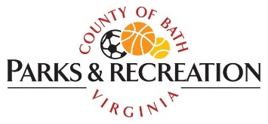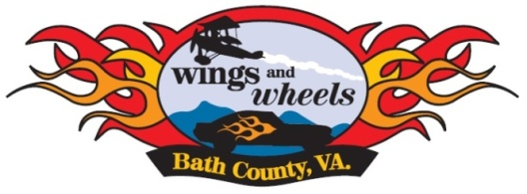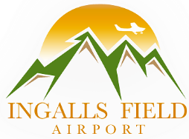
13th Annual Bath County Wings & Wheels
Ingalls Field, 6240 Airport Road, Hot Springs, VA 24445

We would like to offer you an opportunity to be a sponsor for the 13th Annual Bath County Wings and Wheels scheduled for August 26th, 2023 at Ingalls Field nestled high atop the mountains in Hot Springs, Virginia.

The event, which broadcasts live on Allegheny Mountain Radio, WCHG 107.1, includes food, music, and custom car, truck and motorcycle show. This event attracts over 2,000 attendees and is one of the most significant regional shows in our area. With sometimes over 100 entries in the car show and a first-class air show, participants come from all over Virginia and as far away as North Carolina, Ohio, West Virginia and Maryland to attend this unique and exciting event. We believe this is a wonderful opportunity to highlight your business as a sponsor.

We offer several levels of sponsorship. Please see the attached form for a detailed description of each level and what your company will receive for their contribution. If you are interested in becoming a sponsor, please fill out the form and return it with your sponsorship to:

Wings and Wheels 2023
c/o Bath County Parks and Recreation
65 Panther Drive
Hot Springs, VA 24445

We hope you will join us in sponsoring the most successful air and car show in Virginia's Western Highlands. If you have any questions or need further information, feel free to give us a call or email us.

Thank you for your consideration!

Sponsorship Opportunities

Platinum: ($1,000 and above)
Your company name on promotional materials.
Your company announced during radio promotions.
10 Wings and Wheels t-shirts.
10 admission passes
Free booth space for your company
Announcement of your business during the event

Gold: ($500- $999.00)
Your company name on promotional materials.
Your company announced during radio promotions.
6 Wings and Wheels t-shirts
6 admission passes
Free booth space for your company
Announcement of your business during the event

Silver: ($250- $499)
Your company name on promotional materials.
Your company announced during radio promotions.
4 Wings and Wheels t-shirts.
4 admission passes
Announcement of your business during the event

Bronze: ($100- $249)
Your company name on promotional materials.
Your company announced during radio promotions.
2 Wings and Wheels t-shirts.
2 admission passes
Announcement of your business during the event

Sponsor: ($50 or In-Kind Items)
Your company name on promotional material.

Sponsor the purchase of Wings and Wheels t-shirts: ($500)
Sponsor the purchase of car show trophies: ($300)
Your company will be recognized on materials and announced during the event.

*We will also accept items for goodie bags (keychains, coupons, pens, hats, etc..) and items for door prizes. Approximate dollar value of the items donated will determine your sponsorship level.

Sponsor Name: ________________________________________________________
Mailing Address:________________________________________________________
City:__________________________ State:________________ Zip: ______________
Phone #: _____________________________________________________________
Email: _______________________________________________________________
Website: _____________________________________________________________
Sponsorship Level:
T-Shirts ($500) _____ Trophies ($300) _____
Platinum: _____ Gold:_____ Silver: _____ Bronze: _____ Sponsor: _____
Goodie items: _____ $Value______ Door Prize: _____$Value______
Description:________________________________________________________________________________________________________________________________________________________________________________________________________

Please make checks payable to: Bath County Parks and Recreation

Mail check and form to: Wings and Wheels 2023
Bath County Parks and Recreation
65 Panther Drive
Hot Springs, VA 24445

Items can be dropped off at the Bath County Parks and Recreation office. Contact Shannon Gwin at 540-839-7211 or sgwin@bathcountyva.org with any questions.

